Force Storage:

For a robot to throw an object kinetic energy needs to be added to the system. To insert as much energy as possible, bungee cord and clamps were used to provide more tension than the system could otherwise generate. **Figure XXX** shows a generic breakdown of the forces / distances involved in the force storage mechanism for a single cable.

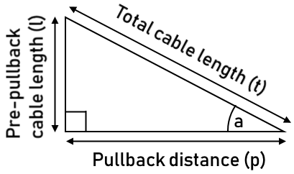

If the system did not incorporate clamps then the total cable tension, $F_{t}$, would be determined by the Dynamixel MX-64. As such, this tension would be shared between the pre-pullback cable length, $F_{l}$, and the pullback distance, $F_{p}$. This can be calculated as:

$$a=\operatorname{atan}\left(\frac{l}{p}\right) \\ F_{t}=F_{MX-64} \\ F_{p}= F_{t}*\cos\left(a\right) \\ Total pullback force, F=4* F_{p}$$

The addition of clamps with an elastic cord allows for the **pullback motor** to also insert energy into the system on top of that generated by the MX-64’s. In this setup, the amount of energy added to the system for a given pullback distance depends on the material properties of the cord. Assuming a linearly elastic system, this infers the total pullback force is:

$$F_{t}=F_{MX-64}+\left(t-l\right)*k \\ Total pullback force, F=4*F_{t}*\cos\left(a\right)$$

Where $k$ is the materials spring constant. For a non-linearly elastic system more energy can be stored as the cable is deflected. For the system given, it is estimated that $F_{t}$ is at least 37N upon full extension.